HTML Code Breakdown
LogGuard AI — NLP-Based Log Anomaly Detection
A detailed part-by-part analysis of the website HTML, CSS, and JavaScript
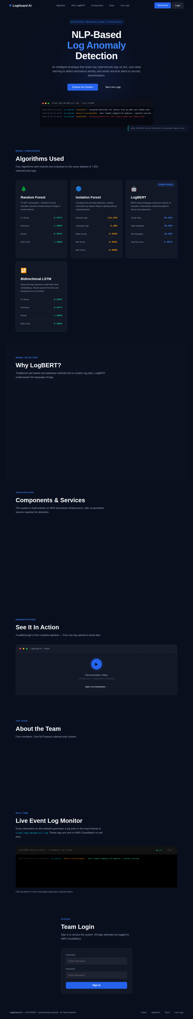
Full page overview of LogGuard AI website

1. Document Overview
This document provides a complete part-by-part explanation of the index.html file for the LogGuard AI website — a CQUniversity COIT20265 project dashboard. The file is a single-page application (564 lines) containing HTML structure, embedded CSS styles, and inline JavaScript — all in one file.

The website is divided into these major parts:
- Lines 1–7: Document head — meta, title, Google Fonts
- Lines 8–172: Embedded CSS styles (all visual design)
- Lines 174–406: HTML body — 9 visible sections + footer + toast
- Lines 408–562: JavaScript block — all interactivity and logic

2. Part 1 — The <head> Section (Lines 1–7)
The <head> block sets up foundational document settings before anything is rendered on screen. It is invisible to the visitor but essential for how the browser interprets and displays the page.

2.1 DOCTYPE and HTML Tag (Lines 1–2)
<!DOCTYPE html>
<html lang="en">
Line 1 tells the browser this is a modern HTML5 document. Line 2 opens the HTML element and sets the language to English, which helps screen readers and search engines.

2.2 Meta Tags (Lines 4–5)
<meta charset="UTF-8">
<meta name="viewport" content="width=device-width, initial-scale=1.0">
charset="UTF-8" ensures all characters (including special symbols) display correctly. The viewport meta tag makes the website responsive — it tells mobile browsers not to zoom out and instead scale to the device width.

2.3 Page Title (Line 6)
<title>LogGuard AI — NLP-Based Log Anomaly Detection</title>
This text appears in the browser tab, bookmarks, and search engine results.

2.4 Google Fonts (Line 7)
<link href="https://fonts.googleapis.com/css2?family=Syne:wght@400;600;700;800&family=DM+Sans:wght@300;400;500&family=DM+Mono:wght@400;500&display=swap" rel="stylesheet">
Three typefaces are loaded from Google Fonts:
- Syne — Used for headings (h1, h2, logo). Bold and modern.
- DM Sans — The main body font for paragraphs and buttons.
- DM Mono — Monospace font used for log output and code-style text.

3. Part 2 — The CSS Styles (Lines 8–172)
All visual styling for the entire website is written inside a single <style> block in the <head>. There is no separate CSS file. Below is each CSS region explained.

3.1 CSS Variables / Colour Palette (Lines 9–23)
:root { --navy: #0a0f1e; --blue: #2563eb; --cyan: #06b6d4; --green: #10b981; ... }
The :root block defines global CSS custom properties (variables). Every colour used on the site is defined here once and referenced throughout. This means changing --blue in one place updates every button, link and highlight simultaneously.
- --navy / --navy2 / --navy3: Dark background colours (near-black blues)
- --blue / --blue2: Primary action colour for buttons and highlights
- --cyan: Used for hostname text in log outputs
- --green: Success states, normal log lines, status dots
- --red: Anomaly/error states in log lines
- --orange: Warning states and service names in logs
- --muted: Secondary grey text throughout
- --border: Subtle white border with low opacity
- --card: Glass-effect card background

3.2 Global Reset & Base Styles (Lines 24–26)
*, *::before, *::after { box-sizing: border-box; margin: 0; padding: 0; }
html { scroll-behavior: smooth; }
body { font-family: DM Sans; background: var(--navy); color: var(--white); overflow-x: hidden; }
The universal selector (*) resets all browser defaults so every element behaves consistently. scroll-behavior: smooth enables animated scrolling when nav links are clicked. The body sets the dark navy background and white text.

3.3 Custom Scrollbar (Lines 27–29)
::-webkit-scrollbar { width: 4px; }
::-webkit-scrollbar-thumb { background: var(--blue); border-radius: 2px; }
This gives Chrome/Edge/Safari a slim 4px blue scrollbar on the right side of the page instead of the default chunky grey one.

3.4 Navigation Bar Styles (Lines 31–49)
The nav CSS makes the top bar:
- Fixed to the top of the screen (position: fixed) — it stays visible while scrolling
- Uses backdrop-filter: blur(20px) for a frosted glass effect over content below
- The .logo-dot gets a pulse animation (keyframe defined at line 42)
- .nav-btn is the blue "View Demo" button — hover lifts it with translateY(-1px)
- .nav-btn-ghost is the transparent "Login" button with a subtle border

3.5 Hero Section Styles (Lines 51–66)
The hero takes up the full viewport height (min-height: 100vh) and centres its content. Two decorative elements are defined here:
- .hero-grid: A CSS grid pattern background made with repeating linear-gradients and masked with a radial gradient so it fades at the edges
- .hero-glow: A large blurred blue radial-gradient circle positioned behind the heading text
- @keyframes fadeUp: The animation that makes the badge, heading, subtitle and buttons fade in from below (used via animation-delay to stagger each element)

3.6 Log Ticker Styles (Lines 68–82)
These styles define the terminal-style log window visible at the bottom of the hero. It uses monospace font (DM Mono) and colour-codes each part of a log line:
- .log-ts — Timestamp in dark grey
- .log-host — Hostname in cyan
- .log-svc — Service name in orange
- .log-msg — Message text in light grey
- .log-msg.anomaly — Red for anomalous events
- .log-msg.warn — Orange for warnings

3.7 Section & Card Styles (Lines 84–133)
These classes control all the main content cards across the site:
- .why-card — The "Why LogBERT?" feature cards. Hover adds a blue border and lifts by 3px.
- .comp-card — The architecture component cards. Hover adds a cyan border.
- .team-card — Team member cards. Hover adds a blue border and lifts.
- .comp-badge — Small coloured pill labels (AWS, ML, UI, Alerts)
- .avatar — Circular initial icons for team members

3.8 Monitor Section Styles (Lines 135–152)
Styles the live log monitor which has a pure black (#000) background to look like a real terminal. Log lines are colour-coded identically to the hero ticker but with slightly different class names (.ml-msg.anom, .ml-msg.warn, .ml-msg.ok).

3.9 Toast Notification Styles (Lines 159–164)
The toast system shows small popup notifications in the bottom-right corner whenever a user interaction is logged. Each toast:
- Has a 3px left border coloured green (normal), red (anomaly), or orange (warning)
- Uses @keyframes toastIn to slide in from the right
- Is fixed-positioned and stacks vertically

3.10 Responsive Styles (Lines 166–171)
@media(max-width: 768px) { nav { padding: 1rem 1.5rem; } .nav-links { display: none; } ... }
At screen widths below 768px (phones and small tablets), the navigation links are hidden, section padding is reduced from 4rem to 1.5rem, and layout spacing is tightened. This is the only media query in the file.

4. Part 3 — The HTML Body (Lines 174–406)
The body contains nine visible sections plus a footer and a hidden toast container. Each section is explained below with its line numbers and a screenshot.

4.1 Navigation Bar (Lines 176–193)
The fixed navigation bar with logo, links, and action buttons
The <nav> element contains:
- Logo (Line 178): An <a> tag linking to #hero with a pulsing blue dot beside the text "LogGuard AI". Clicking it calls logEvent() to record the interaction.
- Nav Links (Lines 182–188): Five anchor links — Algorithm, Why LogBERT, Components, Team, Live Logs — each calling logEvent() on click for CloudWatch logging.
- Action Buttons (Lines 190–191): "View Demo" (blue button → jumps to #demo) and "Login" (ghost button → jumps to #login).

4.2 Hero Section (Lines 195–218)
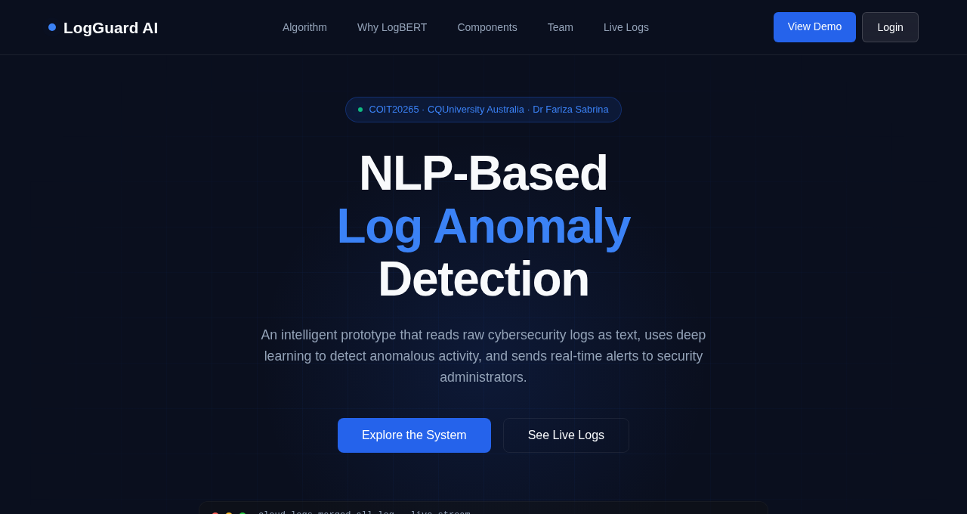
Hero section with heading, subtitle, CTA buttons, and live log ticker
The hero is the full-screen landing area at the top of the page. It contains:
- Background effects (Lines 197–198): .hero-grid (CSS grid overlay) and .hero-glow (blue radial glow) — purely decorative.
- Badge (Lines 200–203): A small pill showing "COIT20265 · CQUniversity Australia · Dr Fariza Sabrina" with a pulsing green dot.
- Heading (Line 204): "NLP-Based Log Anomaly Detection" in Syne font. The words "Log Anomaly" are wrapped in <span> to colour them blue.
- Subtitle (Line 205): A short description paragraph.
- Buttons (Lines 207–208): "Explore the System" scrolls to #algorithm; "See Live Logs" scrolls to #monitor. Both use JavaScript smooth scrolling.
- Log Ticker (Lines 210–216): A macOS-style terminal window (with red/amber/green dots) containing a div#log-feed that is populated by JavaScript with streaming log lines every 1.8 seconds.

4.3 Algorithm Section (Lines 220–290)
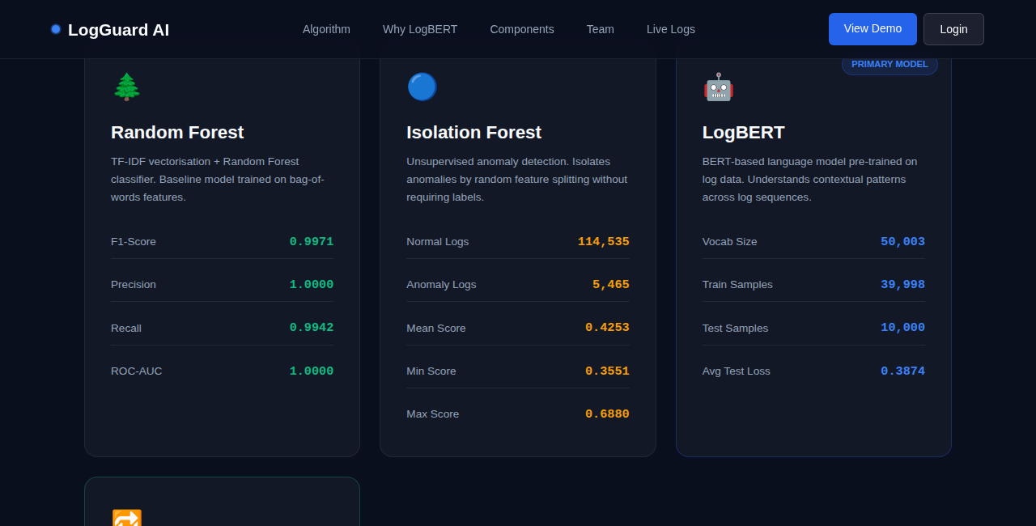
Algorithm cards showing model metrics for Random Forest, Isolation Forest, LogBERT, and LSTM
This section presents four algorithm comparison cards in a responsive CSS grid. Each card contains:
- An emoji icon and algorithm name heading
- A short description paragraph
- A table of performance metrics (F1-Score, Precision, Recall, ROC-AUC for supervised models; Normal/Anomaly counts for Isolation Forest)
- LogBERT card (Lines 259–272) has a "PRIMARY MODEL" badge in the top-right corner and a highlighted blue border
- All four cards have onmouseover/onmouseout handlers to change their border colour on hover, and onclick handlers to log the interaction

4.4 Why LogBERT Section (Lines 292–305)
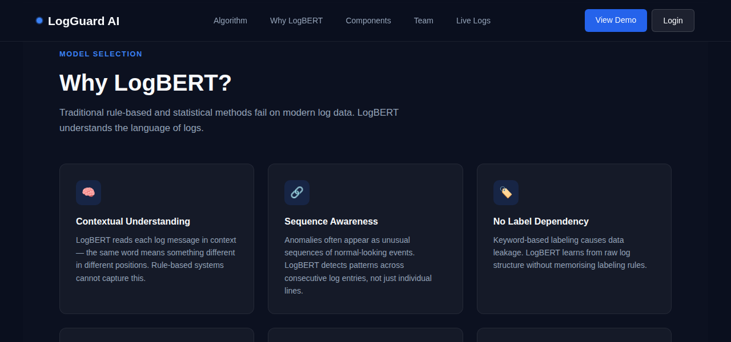
"Why LogBERT?" section with six feature cards
Six .why-card elements arranged in a responsive grid, each explaining a reason why LogBERT was chosen as the primary model:
- Contextual Understanding — LogBERT reads logs in context
- Sequence Awareness — Detects patterns across consecutive entries
- No Label Dependency — Avoids keyword-based data leakage
- Real-World Generalisation — Pre-trained on billions of tokens
- Production Speed — Processes 430 entries in under 2.4 seconds
- Explainable Outputs — Returns probability scores and matched keywords
Every card has an onclick that fires logEvent() to record which card was clicked.

4.5 Components & Services Section (Lines 307–323)
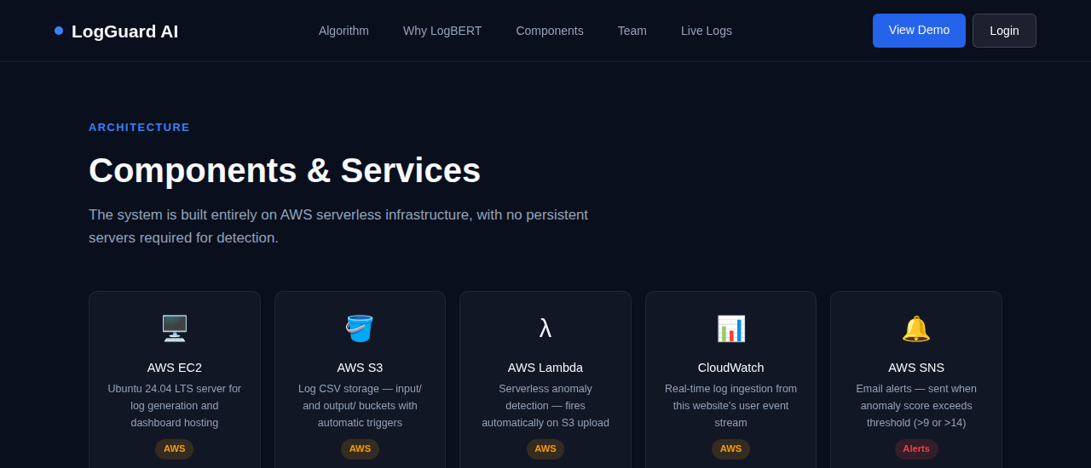
Architecture components grid showing AWS services and ML models
Nine .comp-card elements in a tight grid, each representing one part of the system architecture:
- AWS EC2 — Ubuntu server for log generation and dashboard hosting
- AWS S3 — Input/output CSV buckets with event triggers
- AWS Lambda — Serverless inference engine, auto-fires on S3 upload
- CloudWatch — Ingests user events from this website in real time
- AWS SNS — Sends email alerts when anomaly score exceeds threshold
- LogBERT — Primary BERT model (avg test loss: 0.3874)
- TF-IDF + Random Forest — Baseline model (F1=0.9971)
- Streamlit Dashboard — Visual interface for scores and alerts
- Python Algorithm — anomaly_algorithm.py connecting ML to AWS
Each card has a coloured badge: AWS (amber), ML (blue), UI (green), Alerts (red).

4.6 Demo Section (Lines 325–338)
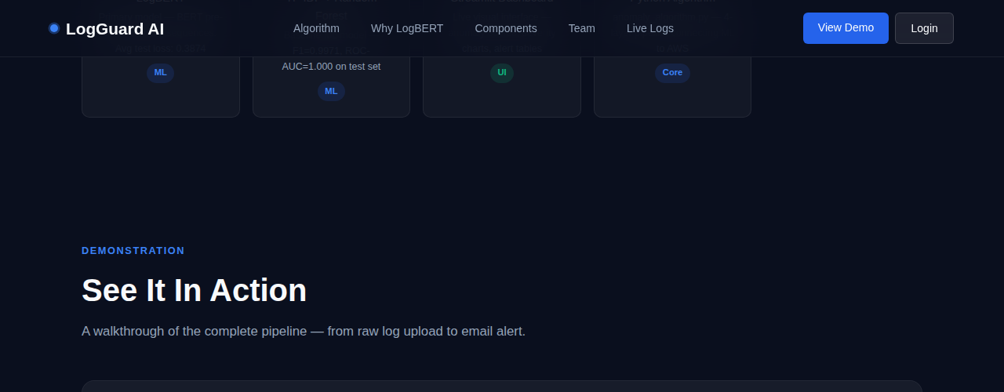
Demo section with play button and link to live Streamlit dashboard
A demo-box with a macOS-style window chrome (three coloured dots). Inside:
- A circular blue play button (▶) — clicking logs the event but no video is attached yet ("Coming soon" message)
- "Open Live Dashboard →" button that opens http://100.31.56.196:8501 in a new tab — this links to the real Streamlit dashboard running on the EC2 instance

4.7 Team Section (Lines 340–351)
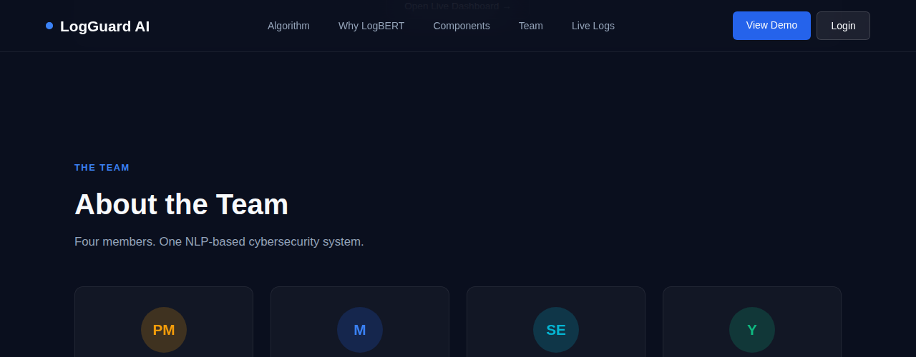
Team section showing four project members with their roles
Four .team-card elements, one per team member:
- Tahmid (PM) — Project Manager: scheduling, reports, stakeholder communication, demo
- Mahin (M) — Cloud Engineer: AWS setup, Python algorithm, log generation, this website
- Nafisa Sultana (SE) — Software Engineer: system integration, architecture, API design
- Yeakub (Y) — Data Analyst / NLP Developer: data preprocessing, model training, evaluation
Each card has a circular avatar with initials, coloured with a different theme (orange, blue, cyan, green).

4.8 Live Event Log Monitor (Lines 353–369)
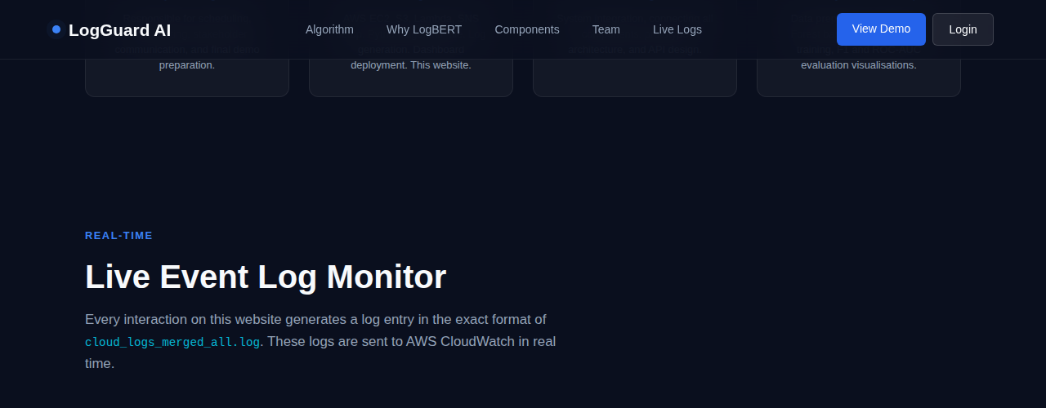
Live event log monitor that records every user interaction on the page
This is a real-time terminal that shows every interaction the user makes on the website formatted as a server log line. The monitor contains:
- A header bar with the stream name, a pulsing green LIVE indicator, and a "clear" button
- A scrollable div#monitor-feed that shows interaction logs as they happen
The explanatory note below the monitor reads: "Click any button or card on this page to generate a log entry above." This demonstrates the logging pipeline — user clicks → JavaScript → CloudWatch.

4.9 Login Section (Lines 371–393)
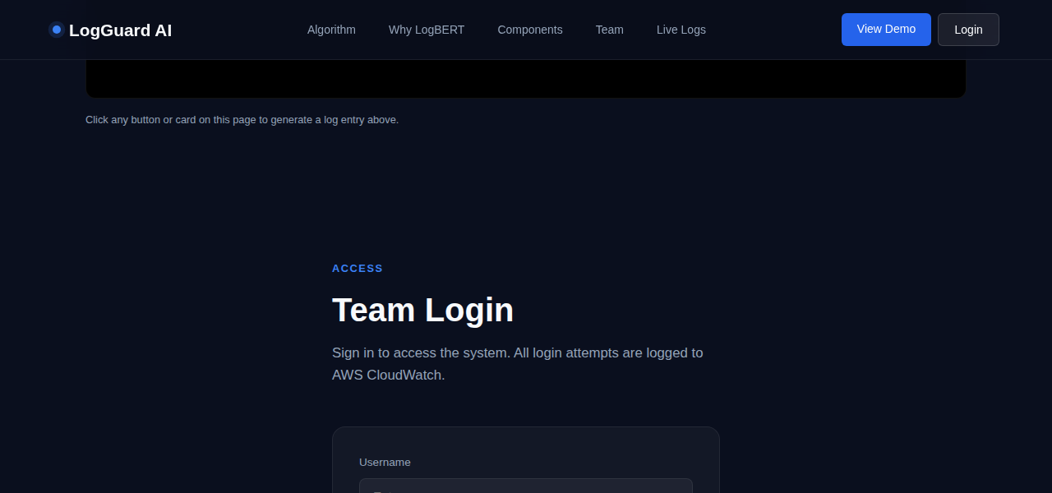
Team Login section with username and password fields
A simple login form for team members. It contains:
- Username input (Line 379–381): Text field with focus/blur border-colour change via onfocus and onblur handlers
- Password input (Lines 385–388): Password field. Pressing Enter triggers doLogin() via onkeydown
- Sign In button (Line 390): Calls doLogin() on click. Hover changes background colour via onmouseover/onmouseout
- Message div (Line 391): Hidden by default. Shows green success or red error messages after login attempt

4.10 Footer (Lines 395–404)
Footer with project credits and navigation links
A simple footer with two parts:
- Left: "LogGuard AI — COIT20265 · CQUniversity Australia · Dr Fariza Sabrina"
- Right: Four anchor links (Home, Algorithm, Team, Live Logs) — each fires logEvent() on click

4.11 Toast Container (Line 406)
<div id="toast-container"></div>
An empty div fixed to the bottom-right of the screen. JavaScript dynamically inserts toast notification elements here whenever logEvent() is called. The container is invisible until toasts appear.

5. Part 4 — JavaScript (Lines 408–562)
All JavaScript is written inside a single <script> block at the bottom of the <body>. Placing scripts at the bottom is best practice — it ensures the HTML has fully loaded before the JS runs. The JavaScript powers six major features:
Summary of All JavaScript Features
Lines | JS Feature / Function | What It Does
411–414 | Visitor IP Fetch | Fetches the real visitor IP from api.ipify.org to embed in log lines as the hostname
416 | PID Counter | Simulates a Unix process ID counter (starts at 1000, increments with each log event)
418 | getTimestamp() | Returns the current ISO timestamp in UTC format for log lines
420–425 | formatLogLine() | Builds a Unix syslog-format log string: timestamp + IP + service[PID]: message
428–439 | sendToCloudWatch() | POSTs log lines to a Flask /log endpoint which forwards them to AWS CloudWatch
442–448 | logEvent() | Master event logger — called by every button and card. Pipes to monitor, ticker, toast, and CloudWatch simultaneously
451–464 | addToMonitor() | Parses a log line and appends a colour-coded row to the live monitor feed div
467–503 | Hero Ticker | Streams simulated SSH/CRON/sudo log entries into the hero terminal at 1.8-second intervals
506–515 | showToast() | Creates a toast popup notification in the bottom-right corner, auto-removes after 2.8 seconds
518–545 | doLogin() | Validates username/password against a hardcoded list. Logs success or failure to CloudWatch
548–554 | IntersectionObserver | Scroll animation — cards fade in from below as they enter the viewport
556–558 | escHtml() | Security helper — sanitises strings before inserting into innerHTML to prevent XSS
560–561 | Page Load/Unload | Logs when a user arrives on or leaves the website

5.1 Visitor IP Detection (Lines 411–414)
fetch('https://api.ipify.org?format=json')
.then(r => r.json())
.then(data => { HOSTNAME = data.ip; })
Purpose: Makes an HTTP GET request to the free public API api.ipify.org which returns the visitor's real public IP address. This IP is then used as the "hostname" field in all generated log lines, making them look exactly like real server logs (e.g. 2025-05-06T10:23:11+00:00 203.12.45.67 website-nav[1001]: User clicked logo).
If the request fails (network error or blocked), HOSTNAME falls back to the string "ip-unknown".

5.2 getTimestamp() — Lines 418
function getTimestamp() { return new Date().toISOString().replace("Z", "+00:00"); }
Purpose: Returns the current date and time in ISO 8601 format with timezone offset instead of the default "Z" suffix. Example output: 2025-05-06T10:23:11.452+00:00. This matches the timestamp format of real Linux syslog entries.

5.3 formatLogLine() — Lines 420–425
function formatLogLine(category, action, message) {
const ts = getTimestamp();
const pid = PID_COUNTER++;
const service = "website-" + category + "[" + pid + "]:";
return ts + " " + HOSTNAME + " " + service + " " + message;
}
Purpose: Assembles the full log line in Unix syslog format. For example, if category="nav" and message="User clicked logo", it produces:
2025-05-06T10:23:11+00:00 203.12.45.67 website-nav[1001]: User clicked logo
This format is identical to real cloud_logs_merged_all.log entries, so these website events can be fed directly into the LogBERT anomaly detection pipeline.

5.4 sendToCloudWatch() — Lines 428–439
async function sendToCloudWatch(logLine) {
await fetch('/log', {
method: 'POST',
headers: { 'Content-Type': 'application/json' },
body: JSON.stringify({ message: logLine })
});
}
Purpose: Sends the formatted log line to a Flask web server running on the EC2 instance at the /log endpoint. The Flask server then forwards the message to AWS CloudWatch Logs. This is how every button click on this website creates a real CloudWatch log entry.
The function is async and uses a try/catch — if the Flask server is unreachable (e.g. running locally), the error is silently logged to the browser console and the website continues to function normally.

5.5 logEvent() — Lines 442–448 (THE CORE FUNCTION)
function logEvent(category, action, message) {
const logLine = formatLogLine(category, action, message);
addToMonitor(logLine, ...);
addToTicker(logLine, ...);
showToast(logLine, ...);
sendToCloudWatch(logLine);
}
Purpose: This is the central function called by every interactive element on the page. When any button, card, or link is clicked, logEvent() is called with three arguments:
- category — which section (e.g. "nav", "hero", "team", "login")
- action — what was clicked (e.g. "logo-click", "play-btn", "login-failed")
- message — a human-readable description (e.g. "User clicked LogGuard logo")
The function determines log severity by checking if the message contains "fail" or "wrong" (which marks it as an anomaly in red). It then sends the log to all four outputs simultaneously: the live monitor panel, the hero ticker, the toast popup, and AWS CloudWatch.

5.6 addToMonitor() — Lines 451–464
Purpose: Parses the raw log line string by splitting on spaces, then dynamically creates a new <div class="monitor-line"> element with four colour-coded <span> elements for timestamp (dark grey), hostname (cyan), service (orange), and message (grey/red/green). The "— waiting for events —" placeholder is replaced on the first real event. The feed is capped at 50 lines to prevent memory growth.

5.7 Hero Ticker & Background Streaming — Lines 467–503
Two separate mechanisms feed the hero log ticker:
- Background simulation (Lines 467–503): Eight pre-written SSH/CRON/sudo log templates (HERO_TEMPLATES array) are cycled through every 1,800ms using setInterval(streamBackground, 1800). This makes the ticker appear to be streaming real server logs even when no user interaction occurs. Templates include both normal logs (green) and anomaly logs (red) to demonstrate the detection system.
- Real event forwarding (Line 493): addToTicker() is called by logEvent() so user-triggered events also appear in the hero ticker in real time.

5.8 showToast() — Lines 506–515
Purpose: Creates a temporary popup notification for every logged event. The toast:
- Appears in the bottom-right corner (positioned by CSS)
- Shows the first 80 characters of the log line
- Has a green left border for normal events, red for anomalies
- Automatically fades out after 2.5 seconds and is removed from the DOM at 2.8 seconds
- Maximum 4 toasts are shown at once — older ones are removed if the limit is exceeded

5.9 doLogin() — Lines 526–545
Purpose: Handles the team login form. It reads values from the username and password input fields, validates them against a hardcoded list of 6 team accounts, and shows a styled message:
- Valid credentials → green success message → logEvent("login", "login-success", ...)
- Wrong credentials → red error message → logEvent("login", "login-failed", ...) — this generates an anomaly-level log in red
- Empty fields → red warning without logging
After each attempt the password field is cleared. The login-failed events are intentionally marked as anomalies (colour red in the monitor) to demonstrate how the system flags suspicious behaviour.
Note: The credentials are stored in plain text in the JavaScript source (lines 518–525). This is a prototype/demonstration only and would not be used in production.

5.10 IntersectionObserver — Lines 548–554
const observer = new IntersectionObserver((entries) => {
entries.forEach(e => { if (e.isIntersecting) {
e.target.style.opacity = "1";
e.target.style.transform = "translateY(0)";
}});
}, { threshold: 0.1 });
Purpose: Creates a scroll-triggered animation. All .why-card, .comp-card, .team-card, and .monitor-line elements start invisible (opacity:0) and shifted down (translateY 20px). As the user scrolls and each card enters the viewport (10% threshold), the observer fires and transitions the card to visible and in position over 0.5 seconds. This creates the "fade up on scroll" effect.

5.11 escHtml() — Lines 556–558
function escHtml(str) {
return String(str).replace(/&/g,"&amp;").replace(/</g,"&lt;").replace(/>/g,"&gt;").replace(/"/g,"&quot;");
}
Purpose: A security helper function that escapes HTML special characters before any string is inserted into innerHTML. This prevents Cross-Site Scripting (XSS) attacks — if a log message somehow contained HTML tags like <script>, they would be safely displayed as text instead of executed as code.

5.12 Page Load & Unload Events — Lines 560–561
window.addEventListener('load', () => { logEvent('system','page-load','User loaded LogGuard AI website — session started'); });
window.addEventListener('beforeunload', () => { logEvent('system','page-unload','User left LogGuard AI website — session ended'); });
Purpose: These two event listeners automatically log when a user arrives on the page (load) and when they leave (beforeunload — triggered by closing the tab, navigating away, or refreshing). This gives session start/end boundaries in CloudWatch, useful for understanding user session duration.

6. Where JavaScript Is Used in the HTML (Inline Events)
In addition to the <script> block, JavaScript is called inline throughout the HTML via onclick, onmouseover, onmouseout, onfocus, onblur, and onkeydown attributes. Here is where each appears:
Line | Element | Event | What It Does
178 | Logo link | onclick | Logs logo click to CloudWatch
183–187 | Nav links (×5) | onclick | Logs which section link was clicked
190 | "View Demo" button | onclick | Logs demo button click
191 | "Login" button | onclick | Logs login button click
207 | "Explore System" button | onclick | Logs + scrolls to #algorithm smoothly
208 | "See Live Logs" button | onclick | Logs + scrolls to #monitor smoothly
228–230 | Random Forest card | onclick + onmouseover/out | Logs click; border colour changes on hover
243–245 | Isolation Forest card | onclick + onmouseover/out | Same hover/log pattern
259–261 | LogBERT card | onclick + onmouseover/out | Same hover/log pattern
275–277 | LSTM card | onclick + onmouseover/out | Same hover/log pattern
298–303 | Why-cards (×6) | onclick | Logs which feature card was clicked
313–321 | Comp-cards (×9) | onclick | Logs which component card was clicked
333 | Play button | onclick | Logs demo play button click
335 | "Open Dashboard" btn | onclick | Logs click + opens Streamlit in new tab
346–349 | Team cards (×4) | onclick | Logs which team member card was clicked
363 | "clear" button | onclick | Clears monitor feed innerHTML
381 | Username input | onfocus / onblur | Blue border on focus, grey on blur
387–388 | Password input | onfocus / onblur / onkeydown | Border change + Enter key triggers doLogin()
390 | "Sign In" button | onclick + onmouseover/out | Calls doLogin(); hover changes background
399–402 | Footer links (×4) | onclick | Logs which footer link was clicked

7. Summary
The LogGuard AI HTML file is a complete single-file website that demonstrates a real-world cybersecurity log monitoring system. Here is what each major technology layer contributes:

HTML (Structure)
Provides nine sections — hero, algorithm comparison, model justification, architecture, demo, team, live monitor, login, and footer — giving visitors a complete overview of the project from concept to implementation.
CSS (Appearance)
Creates a professional dark-mode cybersecurity aesthetic with CSS variables for theming, animations for polish (fadeUp, pulse, slideIn, toastIn), a custom scrollbar, responsive mobile layout, and glassmorphism effects.
JavaScript (Behaviour)
Powers the entire interactive layer: every user action is captured, formatted as a real syslog entry using the visitor's IP address, displayed live in the on-page monitor, shown as a toast notification, and simultaneously forwarded to AWS CloudWatch — demonstrating the actual anomaly detection pipeline in real time.

Total: 564 lines — 1 HTML file · 9 sections · 12 JavaScript functions · 25+ event-tracked interactive elements

